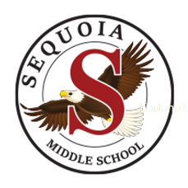
Sequoia Middle School
2021-2022

Regular Day Bell Schedule
Breakfast | 7:30 am | 7:55 am
1 | 8:00 am | 8:52 am
2 | 8:56 am | 9:48 am
3 | 9:52 am | 10:44 am
Eagle Time | 10:48 am | 11:19 am
4A | 11:23 am | 12:15 am
1st Lunch | 11:19 am | 11:54 am
2nd Lunch | 12:15 am | 12:50 pm
4B | 11:58 am | 12:50 pm
5 | 12:54 pm | 1:46 pm
6 | 1:50 pm | 2:42 pm

Minimum Day Bell Schedule
Breakfast | 7:30 am | 7:55 am
1 | 8:00 am | 8:40 am
2 | 8:45 am | 9:25 am
3 | 9:30 am | 10:10 am
4A | 10:15 am | 10:55 am
1st Lunch | 10:10 am | 10:45 am
2nd Lunch | 10:55 am | 11:30 am
4B | 10:50 am | 11:30 am
5 | 11:35 am | 12:15 am
6 | 12:20 am | 1:00 pm
Teacher Inservice | 1:15 pm | 2:42 pm

Minimum days for 2021-2022 school year are every Wednesday and
the following dates: October 19-21 - December 17 - February 23-24
and May 27

